Deploy Python process

We can Deploy Python process using .
1.interactive/foreground method.-(if the process is running it wont allow any other command to execute until its finish, managed manually)
2.Process Management (start and stop will be managed be process management tool)

Task – Deploy Python process on an EC2 by using interactive method .
- Install python - sudo yum install python –y
- Check version - python --version
- Install python package manager-sudo yum install python3 pip
- Install flask package -pip install flask
- Create application page (app.py ) and include the following code .
from flask import Flask
import os

app = Flask(__name__)

@app.route("/")
def hello():
return "updated Flask sample application on azure hghapp service updated version-6"

if __name__ == "__main__":
port = int(os.environ.get("PORT", 5000))
app.run(host="0.0.0.0", port=port, debug=False)

- Run the application (app.py) – python app.py
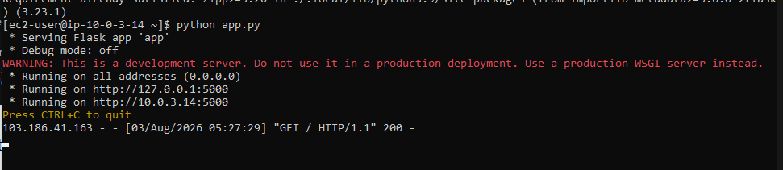
you can see the server started running . now paste the server ip:port in the browser.


You can also check if the process is running or not by using ps aux command.
Since a service is aleady running we can’t give any other command untill unless we end the service.it doesnot allow us to run any other command.
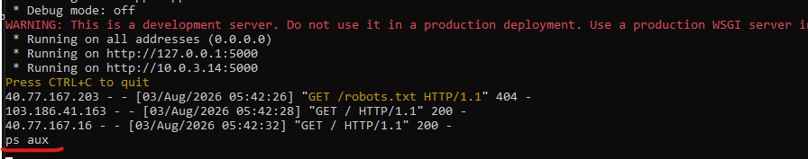

To run any other command we need to end the command or need to push the command in the background.
You can’t see the app.py service running since we end up the service
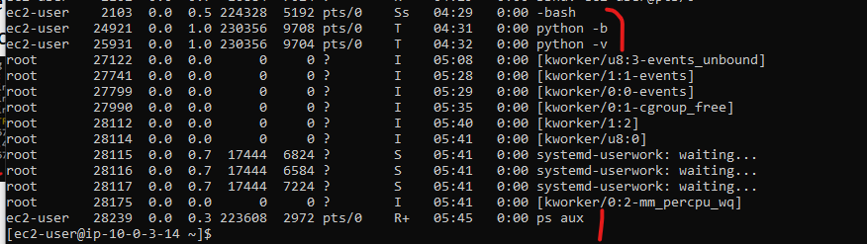

Use ss -tuln to check port 5000 is opened or not .
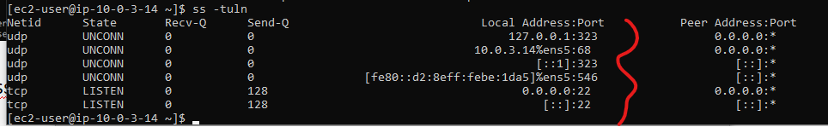

Application is not running . we need to continue the interactive session to keep the service running which is not recommendable .


If you want to check the whether the service is running or not need to open another terminal session and check .
Observe app.py running on pts/0 session and we are checking its status in pts/1 .it is not recommended .
